Registration fee
The language of proceedings is English.
The official languages of the Congress are English, Ukrainian and Russian.

Participation is FREE.

Deadline for manuscripts
Deadline for Manuscripts – September 25, 2018

Registration
Registration of participants
http://congress.nau.edu.ua/2018/en/registration/

How to get to the university

• From the railway station: tramway №1, №3 or route taxi №401 to "National Aviation University" station.

• From “Borispol” airport: airport bus to the railway station, tramway №1, №3 to "National Aviation University" station.

• From Metro "Politekhnichnyi Instytut": route taxi №442 to "National Aviation University" station.

Contacts
The address of the organizing committee
National Aviation University,
1, Kosmonavta Komarova ave., building №1,
room 238,
Kyiv, 03058, Ukraine
Tel: +380 (44) 406-71-56
Fax: +380 (44) 406-79-21
e-mail: congress@nau.edu.ua
http://congress.nau.edu.ua

Memorandum for participants
The language of proceedings is English.
Proceeding will be published on the website:
http://conference.nau.edu.ua/index.php/Congress/Congress2018

Materials submitted for publication should meet the requirements listed below:
– the volume of the article should not exceed 3-5 full pages. Paper size is A5 (148 x210 mm). Margins – 20 mm around;
– an article has to be typed in text editor Microsoft Word, font – Times New Roman – 9, single line space interval between lines.

UDC – left-aligned, space at the bottom 9 pt.

Information about authors – initials, surname, degree in science, in brackets – company, state. Text must be font 9, italic, right-aligned.

Title of the article – font 9, bold, left-aligned, space from above and below – 9 pt, without hyphenation.

Abstract (up to 50 words): font 8, italic, the text must be justified without the first line indent, space from left and right – 5mm, space from below – 9 pt, the text should not be longer than 5 lines.

The text of the article: font 9, first line indent of the paragraph is 10 mm, the text must be justified; captions to figures, font 9, numbering of the tables – font 9, italic, right-alignment; titles of the tables – font 9, the text must be centered; formulas – is recommended to use build-in Word for Windows Equation Editor.

Conclusion: title – font 9, bold, separate section (space from above – 9 pt, from below – 6pt, centered) or inside the text, text – font 9.

References: title (references) – font 9, bold, centered, space from above – 9 pt, from below – 6 pt; text must be typed as numbered list, space from the first line of the paragraph – 5mm, the text must be justified. References should include: author’s surname and initials, title of references, volume etc. – font 9.

Reports will be not edited. Authors are responsible for the content of the report.
MINISTRY OF EDUCATION AND SCIENCE
OF UKRAINE
NATIONAL ACADEMY OF SCIENCES OF UKRAINE
ANTONOV ASTC
NATIONAL AVIATION UNIVERSITY

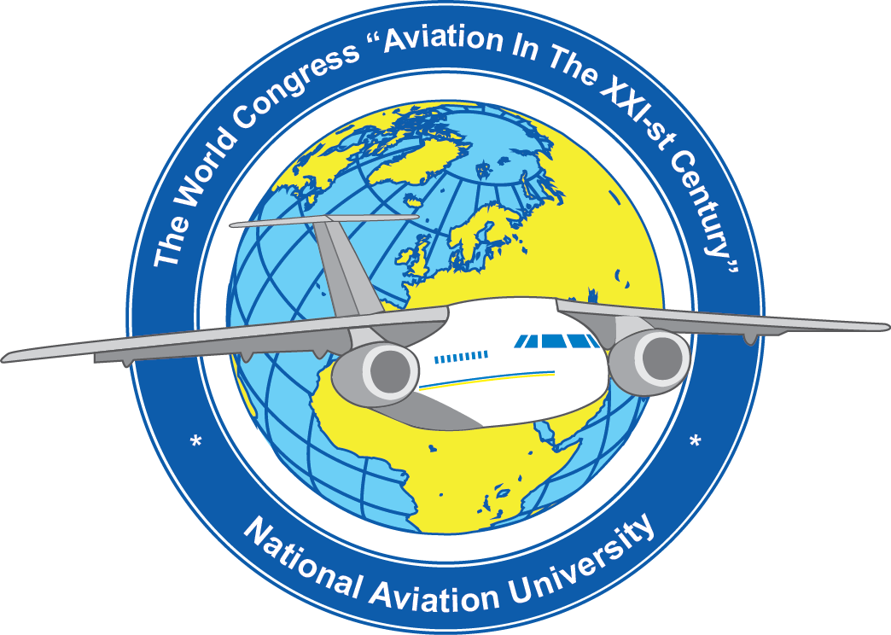

The Eighth World Congress "AVIATION IN THE XXI-st CENTURY" –
"Safety in Aviation and Space Technology"

October 10-12, 2018

Kyiv

Information for participants
Dear Colleagues!
You are welcome to take part in the Eighth World Congress "AVIATION IN THE XXI-st CENTURY" - "Safety in Aviation and Space Technologies", which will be hosted by the National Aviation University, Kyiv, Ukraine on October 10-12, 2018.

The objectives of the Congress
The Congress is aimed at gathering aviation research and industry experts to share ideas on global trends in aviation safety and space technologies as well as to discuss research results and best practices in the area.

Program
http://congress.nau.edu.ua/2018/en/program/

Plenary session on October 11, 2018 at 10:00

Symposia

1. Modern Space and Aviation Technologies
1.1. Automation and energy saving on aviation transport
1.2. Modern technologies of aircrafts airworthiness support
1.3. Aircraft fatigue and fracture
1.4. Modern tribotechnologies in aircraft and general purpose mechanical engineering
1.5. Engines and Power Installations

2. Intelligent Systems and Technology in the Aerospace Area
2.1. Methods and facilities of technical and medical diagnostics
2.2. Automated process control systems
2.3. Information technology and systems in the aviation industry
2.4. Intelligent robotic systems and measuring systems

3. Modern Cybersecurity Challenges
3.1. Information Security Management
3.2. Information & Communication Technologies Security
3.3. Technical Information Security
3.4. Critical Information Infrastructure Protection

4. Information Technologies
4.1. Security of government information resources
4.2. Computer systems
4.3. Advanced information technologies in aviation
4.4. Mathematical modeling and numerical methods

5. Air Navigation: Tendencies and Prospects
5.1. Navigation and air traffic management
5.2. Unmanned aerial systems and complexes
5.3. English in science and engineering: modern challenges
5.4. Avionics and control of complex systems

6. Electronics, Electronic Systems and Technology
6.1. Radar Methods, Systems, and Technologies
6.2. Biomedical Electronics
6.3. Microwaves and Antennas
6.4. Programmable Electronic Systems and IoT Electronic Technology
6.5. Micro- and Nanoelectronic Devices and Systems
6.6. Cryptographic Information Protection in Electronic and Aerospace Systems

7. Environmental Protection

8. International Symposium on Electric Aviation and Autonomous Systems (ISEAS-2018)

9. Aviation Chemmotology

10. Communication Factor in Modern International Relations
10.1. International economic cooperation of Ukraine in the aviation and space fields
10.2. The transformation of journalism in the context of technologizing the world and the processes of globalization
10.3. Information and legal foundations of international relations
10.4. The aviation and the tourism

11. Economics and Management in Aviation

12. Transport Technology and Logistics

13. Human Factor in Aviation
13.1 Social, political, moral and psychological components of aviation safety.
13.2 Psychology of aircraft safe operation and modern ergatic systems.
13.3 Human factor management: current situation and prospects.
13.4 Language modeling of aviation information systems.
13.5 Anthropological and historical-cultural dimensions of aviation safety.

14. Problems of development of the modern airport

15. Air and Space Law: International and National Issues of Security

16. Aspect of the Education Over the Life

17. ICAO Safety Strategies

Contacts
The address of the organizing committee
National Aviation University,
1, Kosmonavta Komarova ave., building №1,
room 238,
Kyiv, 03058, Ukraine
Tel: +380 (44) 406-71-56
Fax: +380 (44) 406-79-21
e-mail: congress@nau.edu.ua
http://congress.nau.edu.ua

